Day-9
Task 1:
Can you create a Maven based spring project using ide.. To print a welcome..note
package org.example;
public class Welcome {
public void display() {
System.out.println("Welcome to Spring Framework");
}
}

Task 2:

Now create a POJO class for student so that can be managed as a spring bean

package org.example.pojo;
public class Student {
private int id;
private String name;
private String course;
public Student() {
System.out.println("Student Object Created");
}
public int getId() {
return id;
}
public void setId(int id) {
this.id = id;
}
public String getName() {
return name;
}
public void setName(String name) {
this.name = name;
}
public void display() {
System.out.println("Student ID : " + id);
System.out.println("Student Name : " + name);
}
}

Task 3:
Configure the above Student bean in the bean-factory-demo.xml file.
That means you need to configure the Student bean in the XML file so the BeanFactory knows how to create it.
And create a main class and run it.. A pictorial rep of the scenario is given below
<?xml version="1.0" encoding="UTF-8"?>
<beans xmlns="http://www.springframework.org/schema/beans"
xmlns:xsi="http://www.w3.org/2001/XMLSchema-instance"
xsi:schemaLocation="
http://www.springframework.org/schema/beans
https://www.springframework.org/schema/beans/spring-beans.xsd">
<bean id="student"
class="org.example.pojo.Student">
<property name="id" value="101"/>
<property name="name" value="Nagurvali"/>
</bean>
</beans>

Pom.xml
<?xml version="1.0" encoding="UTF-8"?>
<project xmlns="http://maven.apache.org/POM/4.0.0"
xmlns:xsi="http://www.w3.org/2001/XMLSchema-instance"
xsi:schemaLocation="http://maven.apache.org/POM/4.0.0 http://maven.apache.org/xsd/maven-4.0.0.xsd">
<modelVersion>4.0.0</modelVersion>
<groupId>org.example</groupId>
<artifactId>BasicCode</artifactId>
<version>1.0-SNAPSHOT</version>
<properties>
<maven.compiler.source>26</maven.compiler.source>
<maven.compiler.target>26</maven.compiler.target>
<project.build.sourceEncoding>UTF-8</project.build.sourceEncoding>
</properties>
<dependencies>
<dependency>
<groupId>org.springframework</groupId>
<artifactId>spring-context</artifactId>
<version>5.3.39</version>
</dependency>
</dependencies>
</project>

Main.java

package org.example;
import org.example.pojo.Student;
import org.springframework.context.ApplicationContext;
import org.springframework.context.support.ClassPathXmlApplicationContext;
public class Main {
public static void main(String[] args) {
ApplicationContext context =
new ClassPathXmlApplicationContext("bean-factory-demo.xml");
Student student = context.getBean("student", Student.class);
student.display();
}
}

Task-04
Can you explain application context with the syntax..
ApplicationContext is the advanced implementation of the BeanFactory interface. It is the most commonly used container in the Spring Framework. It is responsible for creating, configuring, managing, and providing Spring beans throughout the application's lifecycle.

Step 1: Import Required Classes
Step 2: Create the ApplicationContext
Step 3: Retrieve the Bean
Step 4: Use the Bean
Task-05
Why use application context .. plz list some uses?
• Creates and manages Spring beans.
• Supports Dependency Injection (DI).
• Loads bean definitions from XML, annotations, or Java configuration.
• Supports internationalization (i18n).
• Supports event handling.
• Initializes singleton beans eagerly (at startup).
• Provides better functionality than BeanFactory.

Task 6:
What are features of Spring Framework .. list them with 1 or 2 lines explanation?
1. Lightweight
Spring is lightweight because it uses Plain Old Java Objects (POJOs) and requires minimal resources to develop enterprise applications.
2. Inversion of Control (IoC)
Spring manages the creation and lifecycle of objects (beans), reducing the responsibility of the programmer.
3. Dependency Injection (DI)
Spring automatically injects the required dependencies into objects, resulting in loosely coupled and maintainable code.
4. Aspect-Oriented Programming (AOP)
Spring separates cross-cutting concerns such as logging, security, and transaction management from business logic.
Task-07
Why do you think we use spring framework.. Advantages list them down?
Spring Framework is used to develop robust, scalable, secure, and maintainable Java applications. It simplifies enterprise application development by reducing boilerplate code and providing built-in support for dependency management, web development, security, transactions, and database integration.
advantages (List)
- Lightweight
- Loose Coupling
- Dependency Injection (DI)
- Inversion of Control (IoC)
- Modular Architecture
- Easy Integration with other frameworks
- Transaction Management
- Aspect-Oriented Programming (AOP)
- Spring MVC for web applications
- Security Support
- Testing Support
- Flexible Configuration (XML, Java Config, Annotations
Task 8:
What do you understand by IOC? Explain with diagram.
Inversion of Control (IoC) is a core concept of the Spring Framework in which the control of creating and managing objects is transferred from the programmer to the Spring IoC Container.
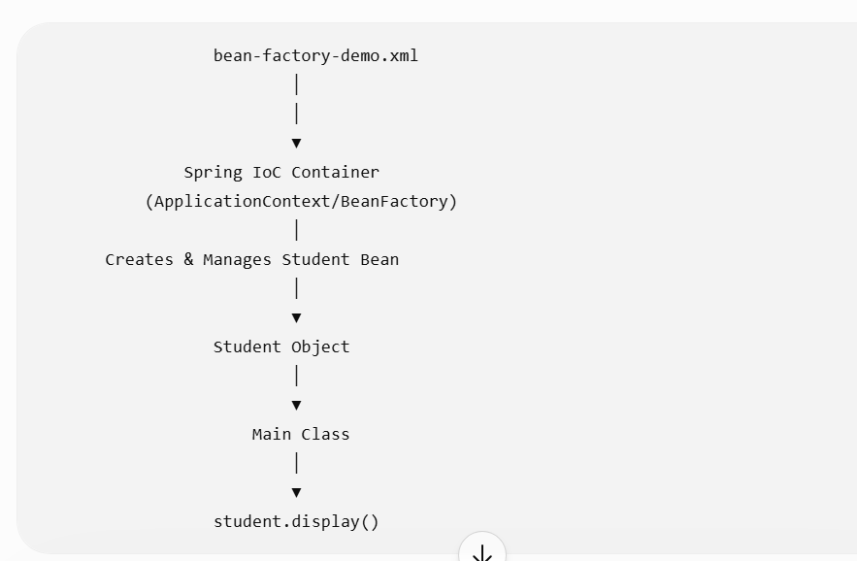

Task-09
How many types of IOC do you have in spring?
What are they with explanation
In Spring, IoC (Inversion of Control) is mainly achieved through Dependency Injection (DI). There are two main types of IoC (Dependency Injection).
1. Constructor Injection
- The required dependencies are provided through the constructor of the class.
- Spring calls the constructor and passes the required objects while creating the bean.

2. Setter Injection
- Dependencies are injected using setter methods after the object is created.
- Spring first creates the object and then calls the setter methods.

Task 10:
What is DI in spring?
Definition
Dependency Injection (DI) is a core feature of the Spring Framework in which the Spring IoC Container provides the required objects (dependencies) to a class instead of the class creating them using the new keyword.

Task-11
How many types of DI do we have? Explain.
In Constructor Injection, the required dependencies are provided to the object through its constructor. Spring injects the dependencies at the time the object is created.

In Setter Injection, Spring injects the dependencies using setter methods after creating the object.
Task-12
What is Spring Application Configuration?
Spring Application Configuration is the process of providing instructions to the Spring IoC Container about how to create, configure, and manage beans (objects) in a Spring application.
Task-13
What are the different ways to configure spring applications?
  - XML-Based Configuration
  - Annotation-Based Configuration
  - Java-Based Configuration

Task-14
Why do we need Spring Application Configuration?
Spring Application Configuration is needed to tell the Spring IoC Container how to create, configure, and manage the application's beans (objects). It provides all the information required for Spring to initialize the application correctly.
Task-15
What are the different ways to configure spring application? Same as 13
  - XML-Based Configuration
  - Annotation-Based Configuration
  - Java-Based Configuration
Task-16
What is bean scope .. give different scopes with description
Bean Scope defines the lifecycle and visibility of a Spring bean. It determines how many instances of a bean Spring creates and how long those instances remain available.

Task-17
What is autowiring in spring?
Autowiring is a feature of the Spring Framework that automatically injects the required dependency (bean) into another bean, eliminating the need to configure dependencies manually in XML or Java configuration.
Task-18
What are diff ways of autowiring?
Spring provides four autowiring modes (used in XML configuration):
- no (Default)
- byName
- byType
- constructor
Task-19
What is diff between a normal java object and Spring bean?
A Normal Java Object is created and managed by the programmer using the new keyword, whereas a Spring Bean is created, configured, and managed by the Spring IoC Container.

Task-20
Difference Between @Component and @Bean
@Component | @Bean
Used on a class. | Used on a method.
Spring automatically detects it during component scanning. | Spring creates the bean from the method's return value.
Suitable for classes that you own and can modify. | Suitable for third-party or external library classes that you cannot modify.
Requires @ComponentScan or Spring Boot's automatic component scanning. | Requires a class annotated with @Configuration.
Used for automatic bean registration. | Used for explicit bean registration with custom configuration.

Task 21:
A different way to create an application using
https://start.spring.io/ try it .. and let me know what is it?
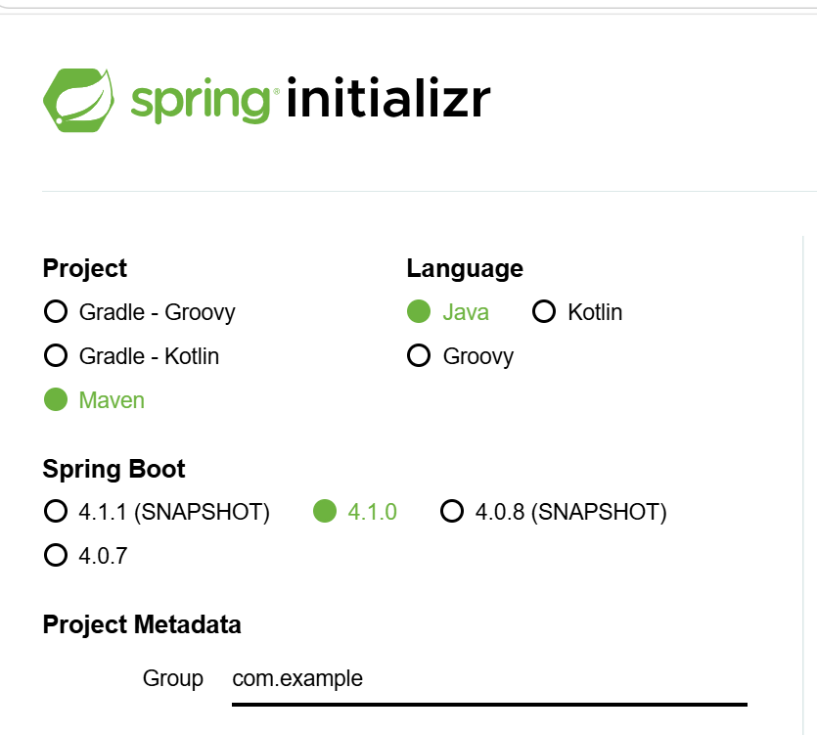
package com.example.Bank;
import org.springframework.boot.SpringApplication;
import org.springframework.boot.autoconfigure.SpringBootApplication;
@SpringBootApplication
public class BankApplication {
public static void main(String[] args) {
SpringApplication.run(BankApplication.class, args);
}
}

Task-23
Annotation | One-line Description
@Bean | Declares a method that returns an object managed by the Spring IoC container.
@Controller | Marks a class as a Spring MVC controller to handle web requests.
@Value | Injects values from properties files or expressions into fields or methods.
@ComponentScan | Tells Spring which packages to scan for components and beans.
@Configuration | Indicates that a class contains bean definitions for the Spring container.
@Service | Marks a class as a service layer component containing business logic.
@Repository | Marks a class as a data access (DAO) component and enables exception translation.
@Qualifier | Specifies which bean should be injected when multiple beans of the same type exist.
@Required | Indicates that a bean property must be set during configuration (deprecated in newer Spring versions).
@Component | Marks a class as a Spring-managed bean for automatic detection during component scanning.
@Autowired | Automatically injects the required dependency into a bean by type.
@Scope | Defines the lifecycle and scope of a bean, such as singleton or prototype
Task-24

Features of Spring Boot
- Auto Configuration – Automatically configures Spring application based on the dependencies present.
- Starter Dependencies – Provides pre-configured starter packages to simplify dependency management.
- Embedded Servers – Includes embedded servers like Tomcat, Jetty, or Undertow, eliminating the need for external deployment.
- Standalone Applications – Allows applications to run independently using a main() method.
- Production-Ready Features – Offers monitoring, health checks, metrics, and management through Spring Boot Actuator.
- Minimal Configuration – Reduces XML configuration by using annotations and sensible defaults.
- Spring Initializr Support – Enables quick project creation with the required dependencies.
- Externalized Configuration – Supports configuration through application.properties or application.yml files.
- Rapid Application Development – Speeds up development by reducing boilerplate code and setup.
- Easy Integration – Integrates seamlessly with Spring modules such as Spring MVC, Spring Data, Spring Security, and Spring Cloud.

Task 25: What are the advantages of Spring Boot?
Spring Boot provides several advantages over traditional Spring development:
- Auto Configuration
  - Automatically configures the application based on the dependencies present in the project.
  - Reduces manual configuration.
- Embedded Server
  - Comes with embedded Tomcat, Jetty, or Undertow.
  - No need to deploy a WAR file to an external server.
- Starter Dependencies
  - Provides starter packages like spring-boot-starter-web and spring-boot-starter-data-jpa.
  - Eliminates dependency version conflicts.
- Minimal Configuration
  - Requires very little XML or Java configuration.

Task 26: What are the key components of Spring Boot?
The key components are:
1. Spring Boot Starters
Predefined dependency bundles for different application types.
Example:
- spring-boot-starter-web
- spring-boot-starter-data-jpa
- spring-boot-starter-security

2. Auto Configuration
Automatically configures Spring beans based on project dependencies.

3. Spring Boot CLI
Allows running Spring applications from the command line without creating a full project.

4. Spring Initializr
Web tool used to generate Spring Boot projects with required dependencies.

5. Actuator
Provides production-ready features like:
- Health Check
- Metrics
- Environment Details
- Application Information

6. Embedded Server
Supports:
- Tomcat (default)
- Jetty
- Undertow

7. Application Properties/YAML
Configuration files:
- application.properties
- application.yml

Task 27: Why Spring Boot over Spring?
Spring Framework | Spring Boot
Requires manual configuration | Auto configuration
External Tomcat required | Embedded Tomcat
Large XML configuration | Little or no XML
Manual dependency management | Starter dependencies
More setup time | Quick project setup
Slower development | Faster development
Complex configuration | Simple configuration
WAR deployment | Executable JAR deployment

Task 28: Explain the internal working of Spring Boot
Step 1
Application starts.
main()
↓
Step 2
SpringApplication.run() is called.
↓
Step 3
Creates the Spring Application Context.
↓
Step 4
Reads the @SpringBootApplication annotation.
↓
Step 5
Performs Component Scanning.
Searches for:
- @Controller
- @Service
- @Repository
- @Component
↓
Step 6
Creates Spring Beans.
↓
Step 7
Performs Dependency Injection.
↓
Step 8
Loads application.properties.
↓
Step 9
Runs Auto Configuration.
Configures:
- Tomcat
- DispatcherServlet
- DataSource
- View Resolver
- Jackson
- etc.
↓
Step 10
Starts Embedded Tomcat.
↓
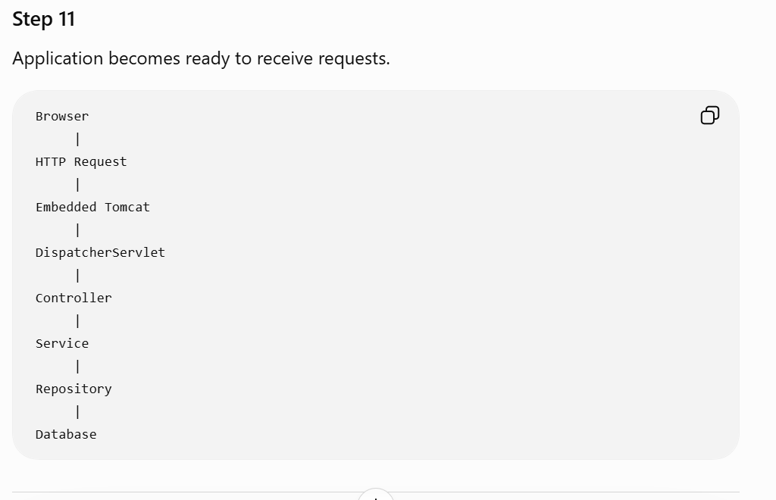
Task 29: List out the starter dependencies for Spring Boot
Some commonly used starter dependencies are:
- spring-boot-starter
- spring-boot-starter-web
- spring-boot-starter-data-jpa
- spring-boot-starter-jdbc
- spring-boot-starter-security
- spring-boot-starter-test
- spring-boot-starter-thymeleaf
- spring-boot-starter-validation
- spring-boot-starter-mail
- spring-boot-starter-cache
- spring-boot-starter-websocket
- spring-boot-starter-actuator
- spring-boot-starter-oauth2-client
- spring-boot-starter-data-mongodb
- spring-boot-starter-data-redis
- spring-boot-starter-batch
- spring-boot-starter-aop
Task 30: Internal working of the given code
import org.springframework.boot.SpringApplication;
import org.springframework.boot.autoconfigure.SpringBootApplication;

@SpringBootApplication
public class MyApplication {

public static void main(String[] args) {
SpringApplication.run(MyApplication.class, args);
}
}
Step-by-Step Explanation
Step 1
JVM starts the application.
↓
Step 2
main() method executes.
public static void main(String[] args)
↓
Step 3
SpringApplication.run(MyApplication.class, args) is called.
This is the entry point of every Spring Boot application.
↓
Step 4
A SpringApplication object is created internally.
↓
Step 5
Reads the @SpringBootApplication annotation.
@SpringBootApplication
This annotation combines three annotations:
@Configuration
@EnableAutoConfiguration
@ComponentScan

@Configuration
Marks this class as a configuration class.
Spring reads bean definitions from this class.

@EnableAutoConfiguration
Automatically configures:
- DataSource
- DispatcherServlet
- Jackson
- Embedded Tomcat
- MVC
- Security (if dependency exists)
- JPA
- View Resolver
based on the project's dependencies.

@ComponentScan
Scans the current package and its sub-packages for Spring components.
Looks for:
@Component
@Service
@Repository
@Controller
@RestController
Creates beans for these classes.

Step 6
Spring creates the Application Context (IoC Container).
↓
Step 7
All Spring Beans are created.
↓
Step 8
Dependency Injection is performed using constructor, setter, or field injection.
↓
Step 9
application.properties (or application.yml) is loaded.
↓
Step 10
Embedded Tomcat starts (default port 8080).
↓
Step 11
DispatcherServlet is initialized.
↓
Step 12
Application is fully started and waits for HTTP requests.
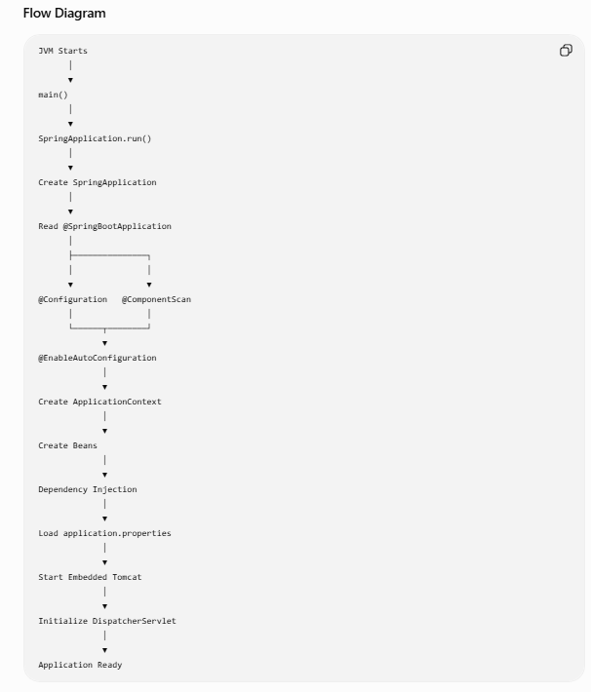

Task 31: Syntax to change the port of the embedded Tomcat server in Spring Boot
Using application.properties
server.port=9090
Now the application runs on:
http://localhost:9090

Using application.yml
server:
port: 9090

Programmatically
import org.springframework.boot.web.server.WebServerFactoryCustomizer;
import org.springframework.boot.web.servlet.server.ConfigurableServletWebServerFactory;
import org.springframework.context.annotation.Bean;
import org.springframework.context.annotation.Configuration;

@Configuration
public class ServerConfig {

@Bean
public WebServerFactoryCustomizer<ConfigurableServletWebServerFactory> webServerFactoryCustomizer() {
return factory -> factory.setPort(9090);
}
}

